Responses to reviewers:

-Reviewer 1

Summary: The paper presents the thermo-mechanical behavior of a hollow sphere (HS) steel and powder metallurgy (PM) aluminum foams over a broad range of elevated temperatures. The experiment and simulation results show that ultra-thin walled presented reversible elastic buckling and large deformation capability. Moreover, oxidation reactions at the surfaces of the cells enhance their mechanical properties at High Temperatures. The paper has a clear goal, and the simulations, experiments and subsequent analysis support the final conclusions of the paper. I recommend this manuscript for publication after minor revision.

Reviewer 1 recommendation: Minor revision.
Here are some specific comments that the authors should address:

Q1: Page 12, Line 209, Page 19, Line 288 et al. Figure ??a and Figure ??b were presented in the manuscript. Please correct the format error and check the whole paper.

Action: We have corrected all formatting errors and checked each figures and citation for accuracy.

Q2:Page 9, Section Mechanical testing. Steel foam specimens were tested at 24 C (ambient temperature), 150 C, 200C, 300 C, 400 ◦C, 550 ◦C, and 700 ◦C, but aluminum foam specimens were tested at 24 ◦C, 150 ◦C, 200 ◦C, 300 ◦C, and 500 ◦C. Why not choose the same testing conditions for two metal foams.

Response: Steel and aluminum have different melting points, and their mechanical properties degrade rapidly at different rates relative to increasing temperature. The mechanical properties of aluminum begin degrading at 100 °C, while those of steel don’t appreciably degrade until 400 °C. For both metals, at least five test temperatures were chosen to span the most relevant temperature range (from 0 % to about 50 % of the melting point, where the most rapid degradation occurs). Table 1 lists the test temperatures, along with their corresponding percentages relative to the melting point temperatures of the aluminum and steel.
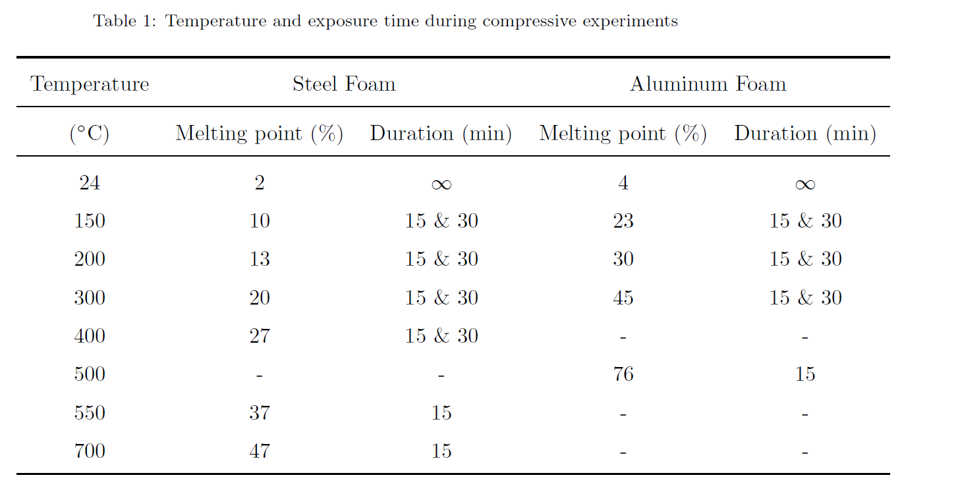

Q3: Please added the nomenclature list of vocabulary of terms in the end of manuscript. For instance, σ, σy, Ep, ε, wapex etc.

Action: A list of acronyms and a list of nomenclature has been added to the end of the article.

-Reviewer 2

Manuscript Number: SUBMIT2IJMS_2019_4099_Original_V1
Title: Mechanical Behavior of Steel and Aluminum Foams at High Temperatures
International Journal of Mechanical Sciences

The authors investigated the thermo-mechanical behavior of hollow sphere (HS) steel and powder metallurgy (PM) aluminum foams at high temperatures. The samples were subjected to the compressive loading at different temperatures and their mechanical properties were measured. Also, the achieved experimental results were compared with those given by a computational micro-model. Standard metrics for characterizing the temperature-dependent performance of the metallic foams were calculated based on ISO Standard 13314:2011, and the behavior was further parametrized by fitting a piecewise nine-parameter\Richard Equation" to the experimental stress-strain data of each specimen. The experimental results showed that the HS steel foam retained more than 89 % of its compressive strength, when measured by the plateau stress, up to 400 ◦C.
The manuscript is generally well written and organized. Also, the topic matches well with the major scope of International Journal of Mechanical Sciences. Nevertheless, before recommending for publication, the following revisions need to address carefully:

Q1: The authors should clearly state in the introduction the novelty in this paper. What is new in this paper that has not been published before in the literature? Experimental tests and computational micro-model have been used already in the literature, so what is the exact contribution of this work?

Response: This manuscript links the micro-mechanics of hollow steel spheres with the homogenized, global behavior of metal foams. This manuscript also examines the influence of elevated temperatures on the mechanical properties of metal foams. The simulations, corroborated with the experiments, allowed for the analytical synthesis based on the unit cell buckling stability, in the context of varying temperature.

The key novelty of this article is its use of micro-simulator, which uses random packing of the spheres, and was able to compute large scale deformations of the micro-model successfully. Results from the micro-simulator were in agreement with macroscopic test results, and also with previously published CT-scan based articles on the internal, local deformation mechanisms.

Equipped with validated, high-resolution results, we observed that local buckling stability controlled the global deformations of the cellular foams. This manuscript synthesized these findings using analytical, closed-form equations for the elasto-plastic stability of a spherical shell. The analysis revealed that the current manufacturing methods produce thick spheres, which are controlled by plastic buckling. However, if ultra-thin spheres were achievable, elastic buckling could produce globally elastic materials with highly-reversible, compressive behavior, akin to natural sponges.

We also used Richard’s equation, fitted to the experimental data, to characterize systematic trends in the degradation of the foams’ material properties at elevated temperatures, because characterization by the Richard equation provides a consistent basis for comparison of the results between temperatures. The experiments also revealed the formation of a blue-oxide film on steel foam cells, which increased its stiffness and strength in the temperature range from 200 °C to 400 °C. These findings underpin the assertion that analytical and computational work always needs to be supported with macroscopic experiments due to the potential for surface changes/oxidations, which might noticeably influence the homogenized, global behavior.

Action: The introduction has been expanded to clearly state the points above.

Q2: What are the advantages of the experimental approach and computational micro-model used in this study? The authors should justify these issues. A comparison between the different experimental approaches to demonstrate their advantages and disadvantages is recommended.

Response: The Micro-model, validated against macroscopic experiments, yielded important insights into the internal mechanics of the metal foams, which could not have been easily measured, especially at elevated temperatures. The model also permitted investigation of local buckling behavior at the cell-level. The supplemental analytical buckling derivations re-confirmed the key findings and trends, and also revealed the potential benefits of ultra-thin-walled cellular metals, which might exhibit hyper-elastic properties. This manuscript’s combination of the macroscopic experimental results and validated micro-model simulations yielded experimentally-validated, high-resolution information, including the locations of induced plastic strains and stresses, which allowed analytical conclusions and insights into the material behavior to be drawn.

Q3: Some advanced concepts should be referred to the adequate references leading the less experienced readers.

Action: The following references on cellular metals were added to the manuscript:
- Ashby, M., 2000. Metal foams : a design guide. Butterworth-Heinemann, Boston
- Gibson, L.J., Ashby, M.F., Ashby, M., 1999. Cellular Solids: Structure and Properties, 2nd ed. Cambridge University Press.
The following references with background information about the micro-simulator were also added to the mansucript:
- Smith, B.H., Szyniszewski, S., Hajjar, J.F., Schafer, B.W., Arwade, S.R., 2012. Characterization of Steel Foams for Structural Components. Metals 2, 399–410.

Q4: Some new physical insights should be added to the revised manuscript.

Response: Several key physical insights were derived from the simulations, analytical, consideration of elasto-plastic stability (of a spherical shell), and experimental results. Firstly, we showed that the macroscopic mechanical properties of the hollow sphere foam were linked with the buckling capacity of spherical shells, which can be identified within each hollow sphere. Thus, wall thickness-to-sphere radius ratio and base material properties are key parameters influencing the global response. We also showed that the load paths followed random trajectories, sensitively depending on the contact points and packing of the spheres. Finally, the stability analysis revealed the potential for achieving elastic buckling of the spheres through use of ultra-thin walls. Such a cellular structure would exhibit reversible, highly compressible behavior.

Our observations also revealed chemical oxidation of the steel foams, which manifested by forming a blue film layer on the surfaces of the cells. This stiffer blue oxide layer increased the macroscopic stiffness of the materials, due to large surface area of the hollow sphere steel foam.

Q5: Conclusion section should be shorten. The main new findings must be given in Conclusion.

Action: The conclusions section has been shortened.

Q6: For a special case, the obtained results need to check with those in open literature.

Response: The original submission compared our experimental data with previously published results for thermal degradation found in the literature below:
- European Comittee for Standardization. Eurocode 3: Design of Steel Structures, Part 1-2: General Rules - Structural Fire Design – EN 1993-1-2:2005
- European Comittee for Standardization. Eurocode 9: Design of Aluminum Structures, Part 1-2: Structural Fire Design – EN 1999-1-2:2007.
- M. Aly, Behavior of closed cell aluminium foams upon compressive testing at elevated temperatures: Experimental results, Materials Letters 61 (2007) 3138–3141.
- J. Kovácik, L. Orovcik, J. Jerz, High-temperature compression of closed cell aluminium foams, Kovové Materiály 54 (2016) 429–440.
- J. Liu, Q. Qu, Y. Liu, R. Li, B. Liu, Compressive properties of al-si-sic composite foams at elevated temperatures, Journal of Alloys and Compounds 676 (2016) 239–244.
- M. Taherishargh, E. Linul, S. Broxtermann, T. Fiedler, The mechanical properties of expanded perlite-aluminium syntactic foam at elevated temperatures, Journal of Alloys and Compounds 737 (2018) 590–596.
The comparison can be found in the Discussion, Section 6.

Q7: In addition to those given in Fig. 10, is it possible to compare the parameters such as the primary resolved shear strain and fatigue life with those given in recently-published works?

Response: The experimental setup, which used a Universal Testing Machine to apply the compressive loading, did not have the means to apply tension or cyclic loading inside the furnace to compute the fatigue life of the foams. Examining the resolved shear strains of metal foams would be an excellent subject for a future study.

Q8: Figures should be modified. No data can be extracted from some figures. For example, see Figures 15 and 16.

Action: The figures were modified so that the data can be extracted. An Excel spreadsheet with all of the measured data was also added as a supplement to the manuscript (in a Supplementary Information section). The parameters of the fitted Richard equation curves are also given in the Supplementary Information.

Q9: References are old. Some new related works need to add the revised manuscript.

Action: The introduction has been revised and expanded to include additional recent references across a variety of materials journals. In addition to the citations included in that section in the previous revision, citations to the following papers were added:
- D.P. Mondal, N. Jha, A. Badkul, S. Das, R. Khedle. “High temperature compressive deformation bahaviour of aluminum syntactic foam.” Materials Science and Engineering A, 534 (2012), 521–529. doi:10.1016/j.msea.2011.16512.002.
- N. Bekoz, E. Oktay. “High temperature mechanical properties of low alloy steel foams produced by powder metallurgy.” Materials and Design, 53 (2014), 482–489. doi:10.1016/j.matdes.2013.07.050.
- N. Movahedi and E. Linul. “Quasi-static compressive behavior of the ex-situ aluminum-alloy foam-filled tubes under elevated temperatures.” Materials Letters, 206 (2017), 182–184. doi:10.1016/j.matlet.2017.07.018.
- E. Linul, N. Movahedi, L. Marsavina. “The temperature effect on the axial quasi-static compressive behavior of ex-situ aluminum foam-filled tubes.” Composite Structures, 180 (2017), 709–722. doi:10.1016/j.compstruct.2017.08.034.
- E. Linul, D. Lell, N. Movahedi, C. Codrean, T. Fiedler. “Compressive properties of zinc syntactic foams at elevated temperatures.” Composites Part B, 167 (2019) 122–134. doi:10.1016/j.compositesb.2018.12.019.

-Reviewer 3

This paper investigates the thermo-mechanical behavior of a hollow sphere steel and powder metallurgy aluminum foams over a broad range of elevated temperatures. The paper is well written; however, before publication, the following improvements are recommended:
Q1: The “Abstract” and “Summary and Conclusions” sections must be written more concisely.

Action: The Abstract and Summary and Conclusions sections have been revised to be more concise.

Q2: Grammatical writing must be unified, whether the UK or the USA English must be used and not both.

Action: The language and grammar have been unified to American English.

Q3. Scale bars must be added to Figure 2.

Action: Scale bars were added to Figure 2.

Q4: Why only two specimens were tested under each temperature condition. According to the standard, at least 3 specimens should be used.

Response: Our number of specimens was restricted by the limited volume of steel and aluminum foam we had available for testing (we sourced one block of each metal foam from Fraunhofer Institutes in Dresden and Chemnitz). The decision was made to have a higher number of points across the temperature range to better capture the material degradation because the decreases in the strength and stiffness of steel and aluminum occur quite abruptly after exceeding their respective transition temperature. We acknowledge the trade-off between temperature-resolution and statistical rigor.

Generally speaking, the manuscript was equally as focused on the simulations and analytical derivations as it was on the experiments. The experiments were primarily used to validate and confirm the insights gleaned from the computational simulations and analytical derivations. From this perspective, the tests can be viewed as blind tests or validation cases.
Q5: “Figure ??” must be named (see end of Section 3.2)

Action: The reference to the figure was corrected.

Q6: The curves in Figure 8 must be plotted with lines not geometrical shapes (square, circles, etc.). These shapes being at a significant distance from each other fail to correctly reproduce the compression behavior.

Action: Lines have been included in the plots, in addition to the geometrical shapes.

Q7. Why are properties at 300C higher than RT or 100C, Figure 8b? In addition, those from 400C are higher than those from 200C. Why? Normally I should be like that.

Response: A thin, blue oxide film coating was observed on all cells of the steel foam at temperatures exceeding 250 °C. This phenomenon is known as blue brittleness. The blue oxide layer is stiffer and stronger, but more brittle than the base steel alloy. Due to the large surface area of the hollow sphere steel foam, the formation of the stiffer film on the cells macroscopically increased the stiffness of the materials, as shown in Figure 8b. The effect was most apparent at temperatures in the 300 °C to 400 °C range. The stiffening of the steel foam due to the blue brittleness effect became negligible at higher temperatures as the base steel degraded, losing its stiffness and strength. The blue brittleness effect can also be observed in Figure 14 (a), where the retained plateau stress peaked at 300 °C. It is also reflected in the stress-strain curves in Figure 8b.

Action: Before introducing Figure 8b, the order of the curves and their underlying mechanisms were clarified. The text was added to the manuscript that explains the effect of the blue oxide film on the steel foam’s stiffness and strength in the range of 300 °C to 400 °C. The figure which shows the blue film on the tested sample was moved to a new location, immediately following the plotted of stress-strain curves in Figure 8b.

Q8: Error bars must be added to Figures 13, 14, 17-19, 21 and and 22.

Action: Error bars are shown below for the plots contained in Figures 13, 14, 17-19, 21, and 22. In these plots, the span of the error bars was determined by adding and subtracting one standard deviation from the average result, where the mean and standard deviation were calculated, assuming that the samples are drawn from a normal distribution.
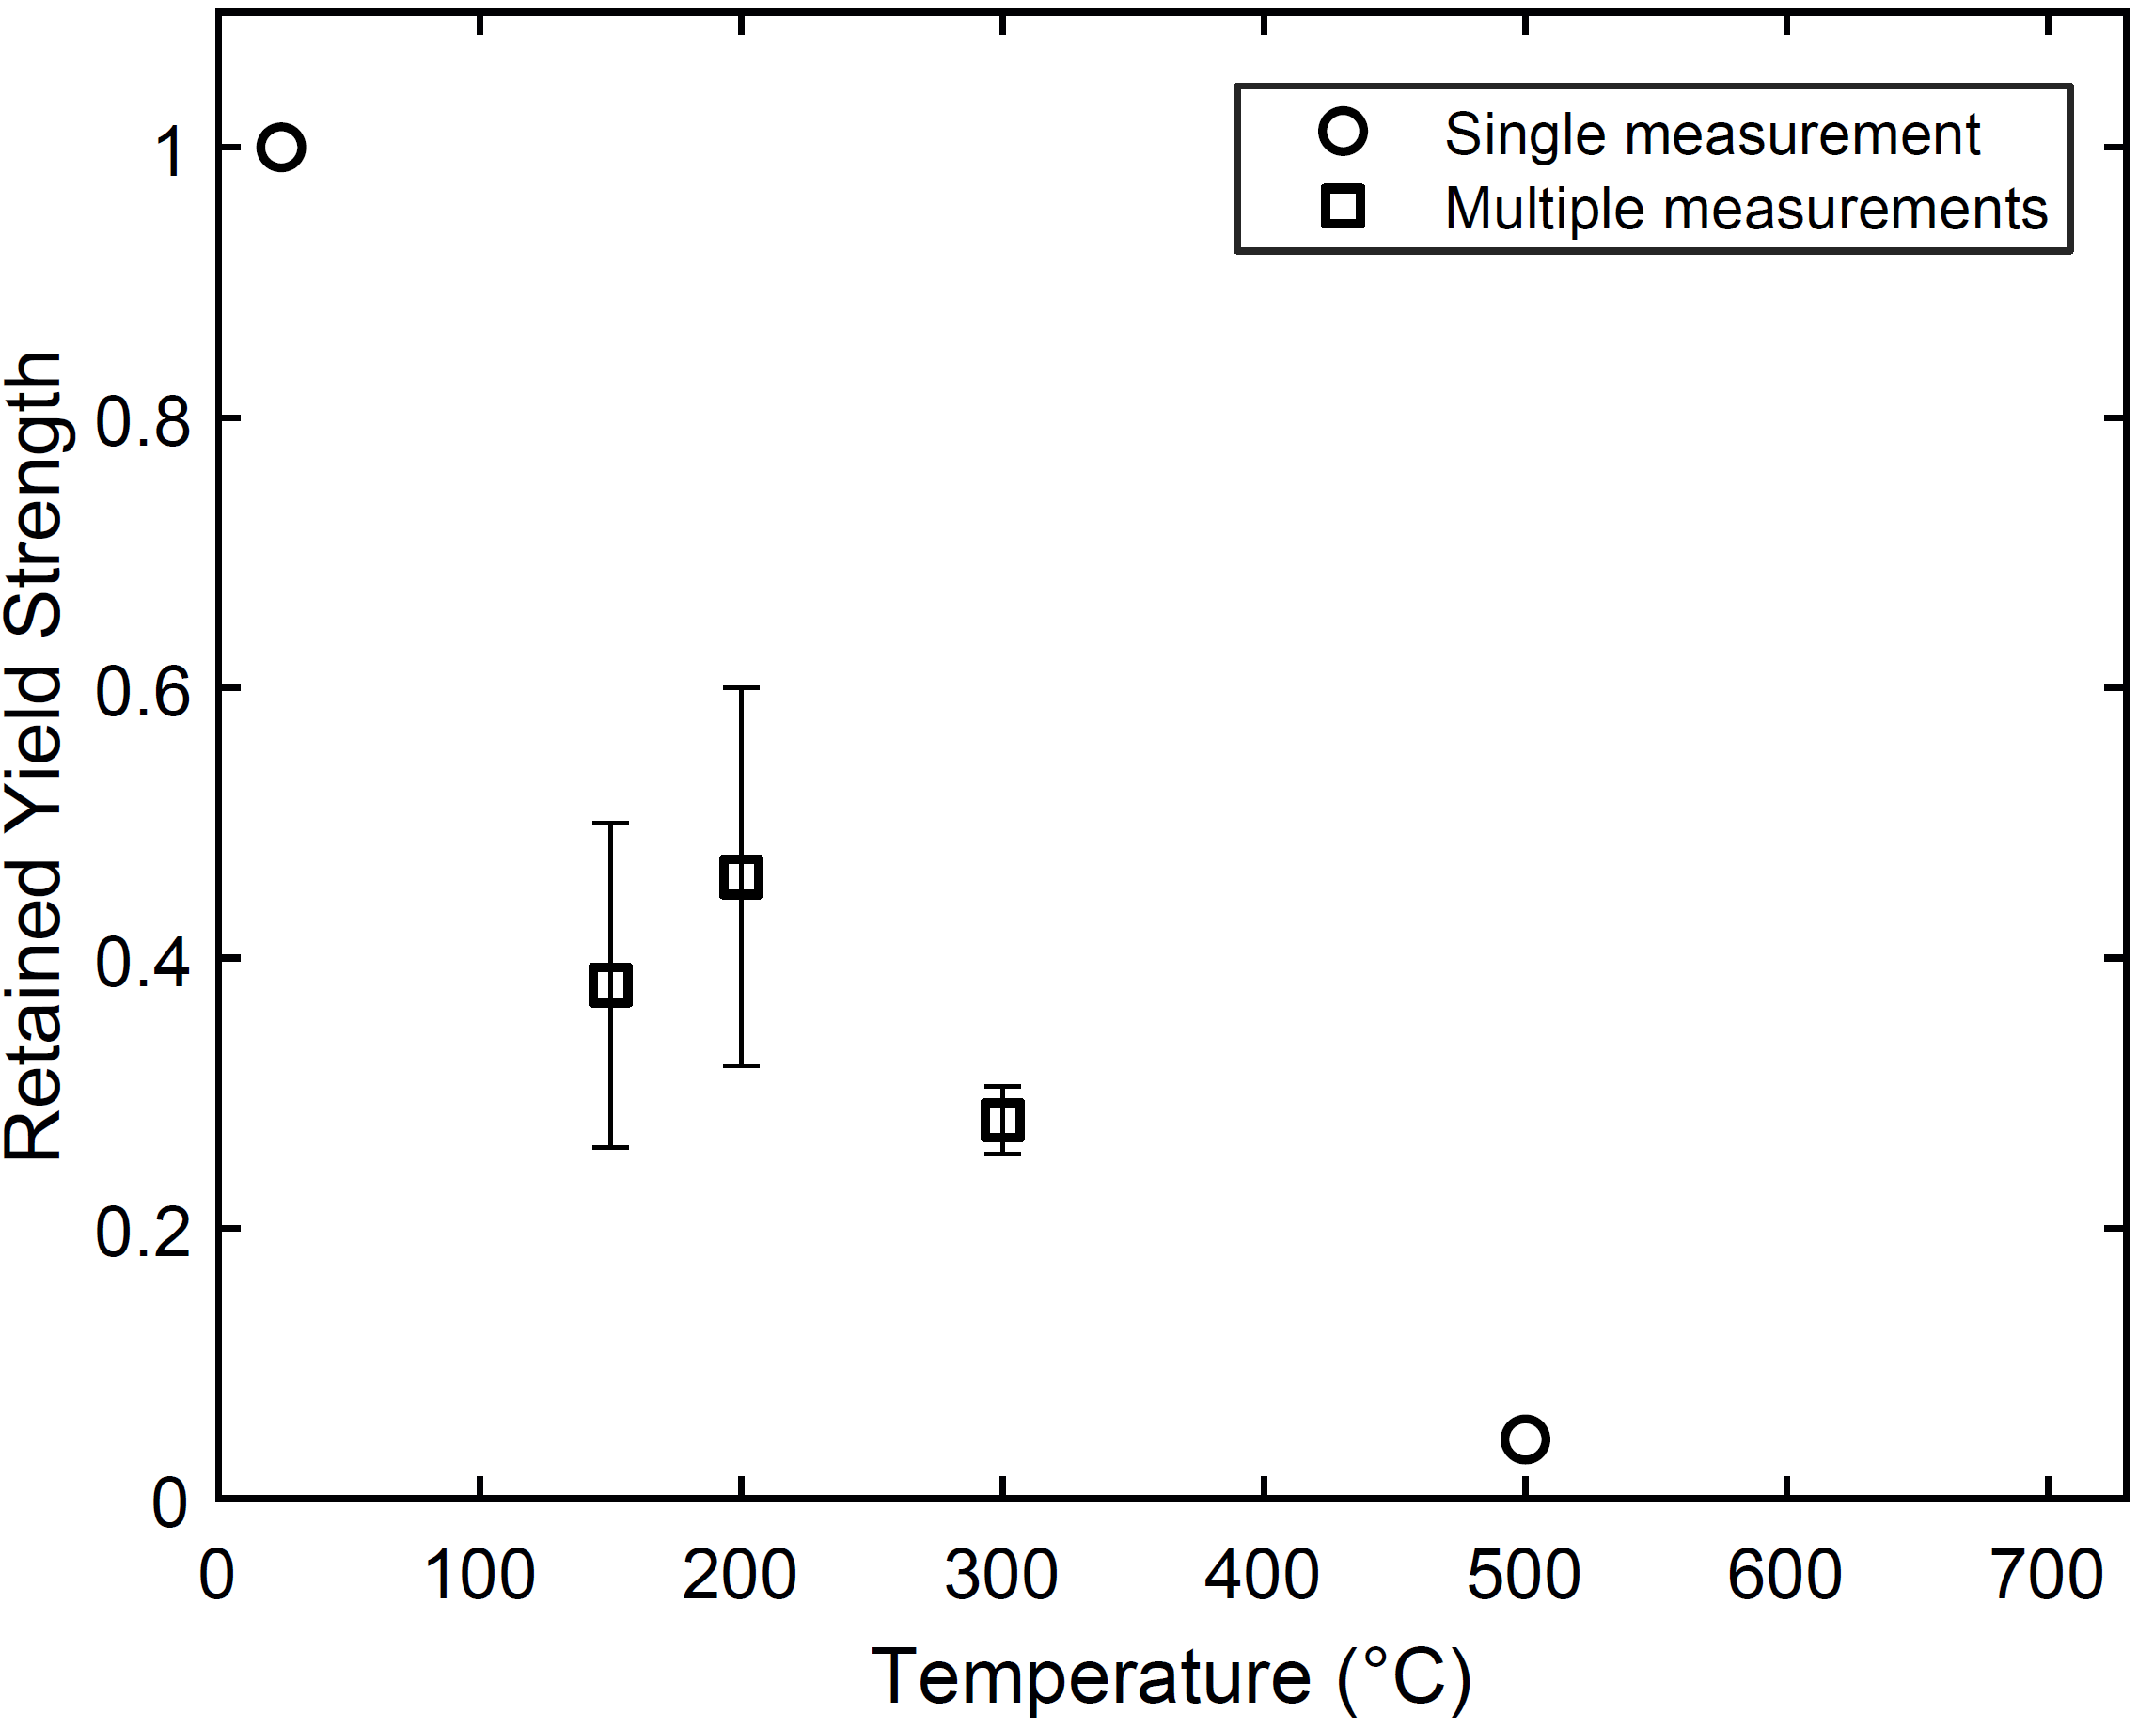
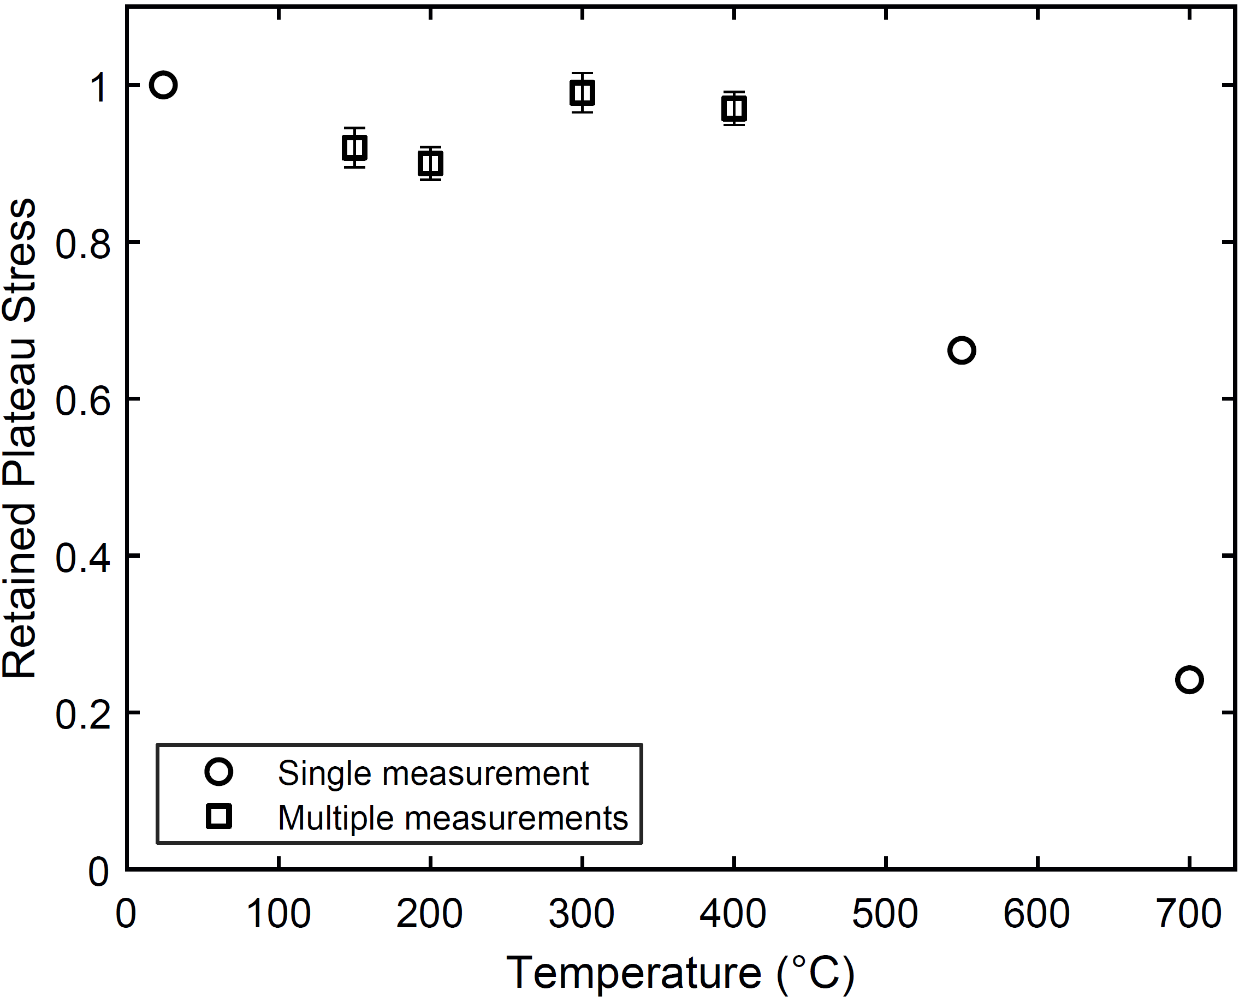
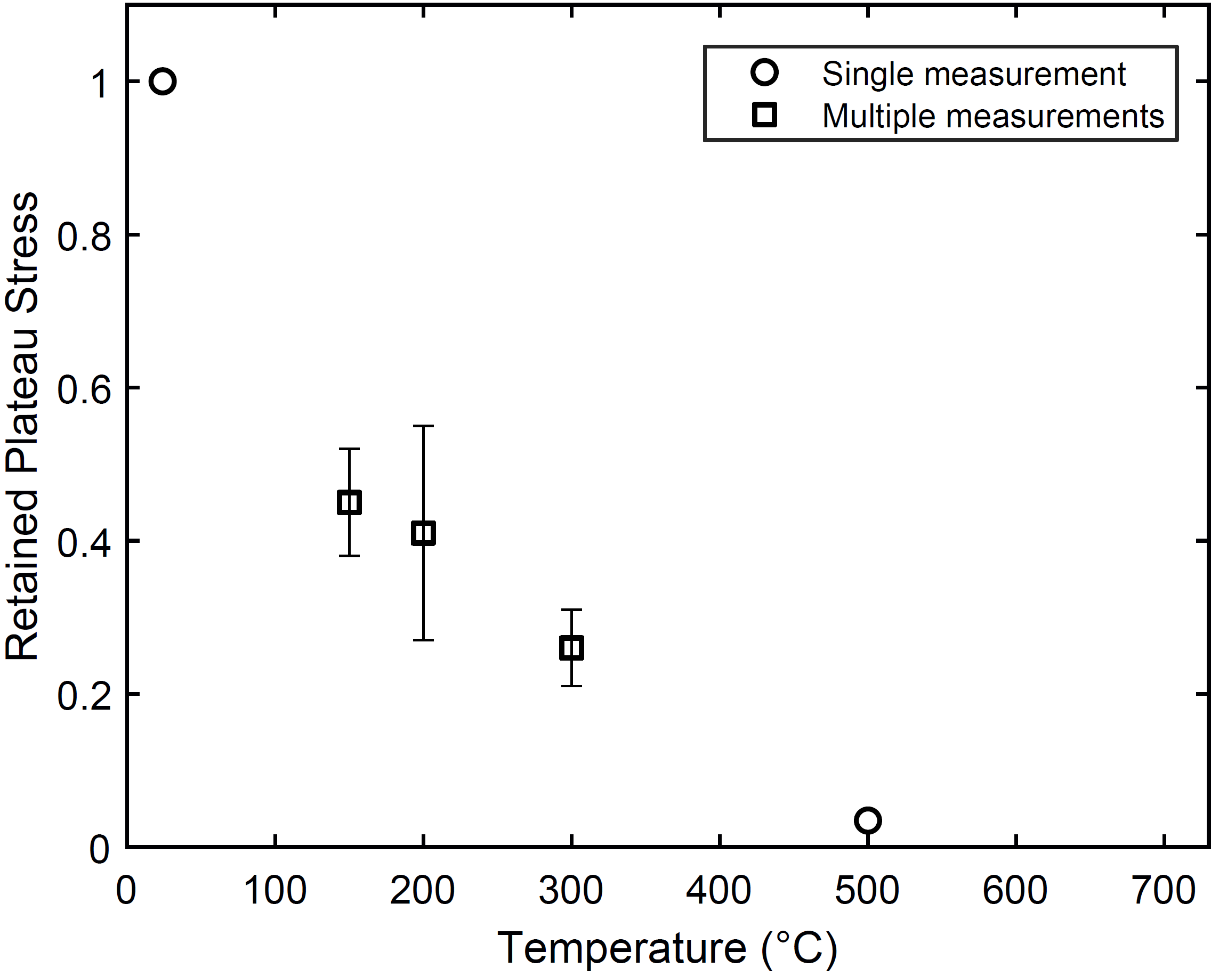

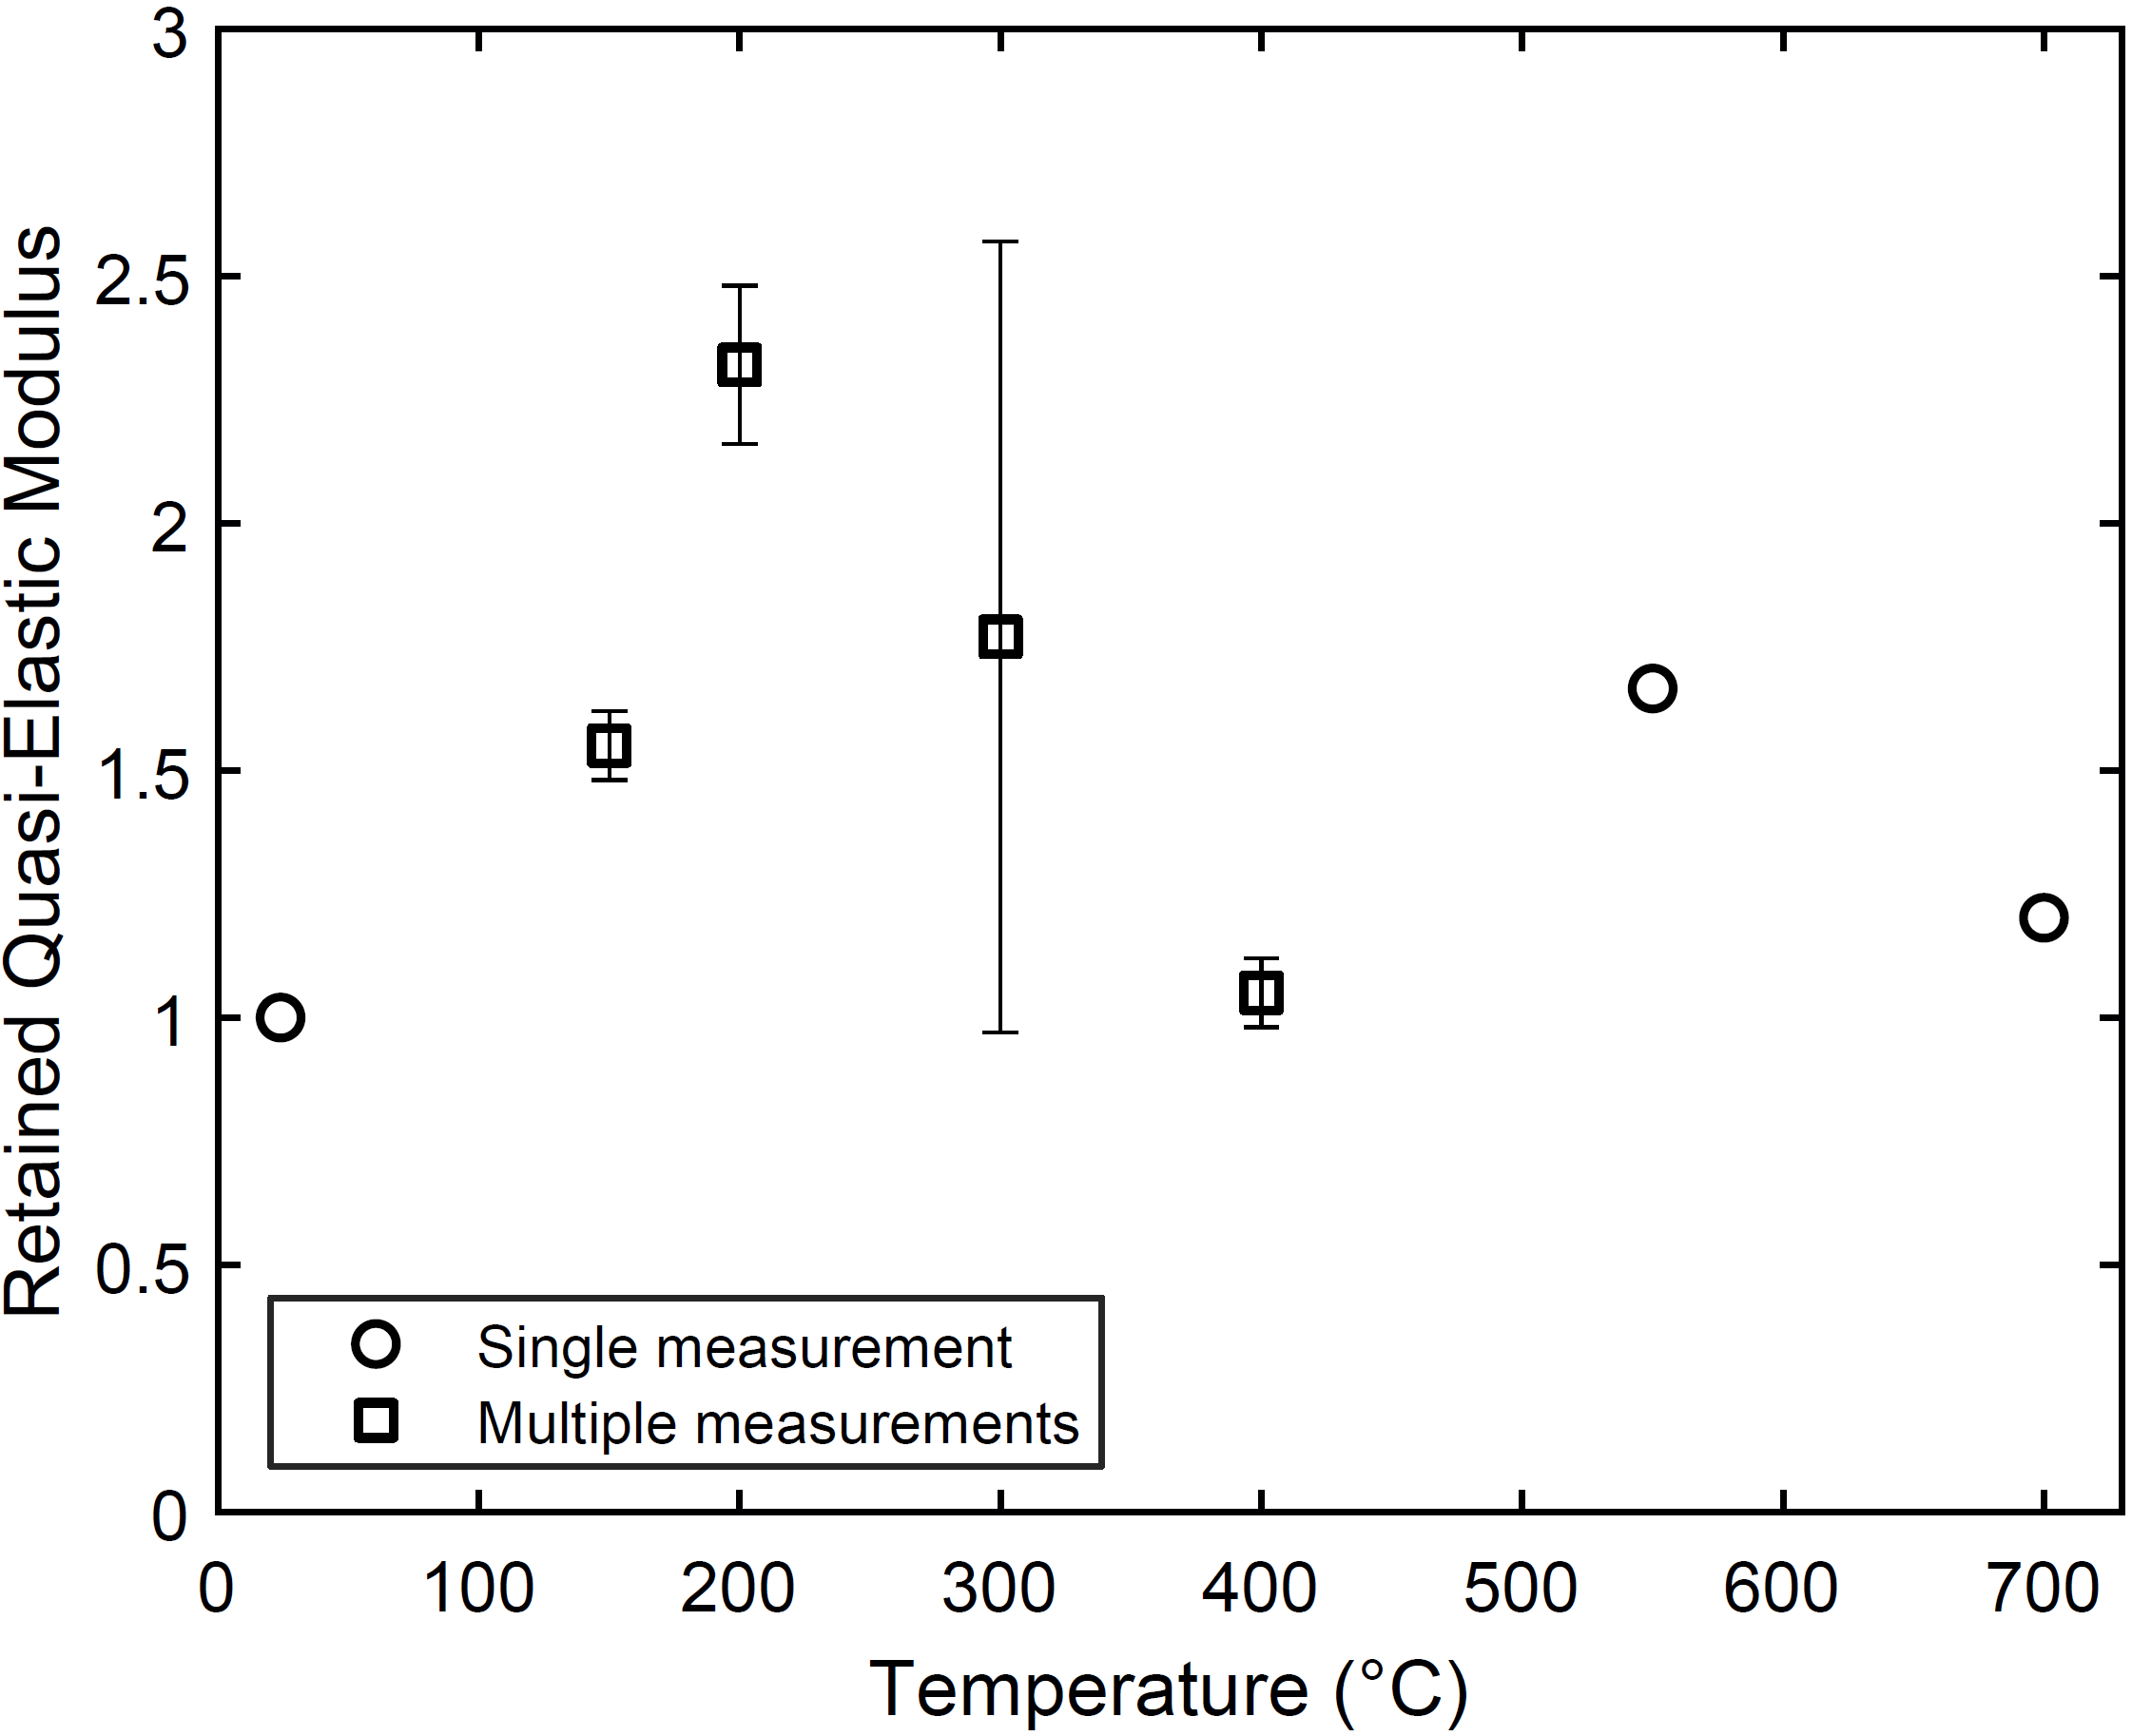
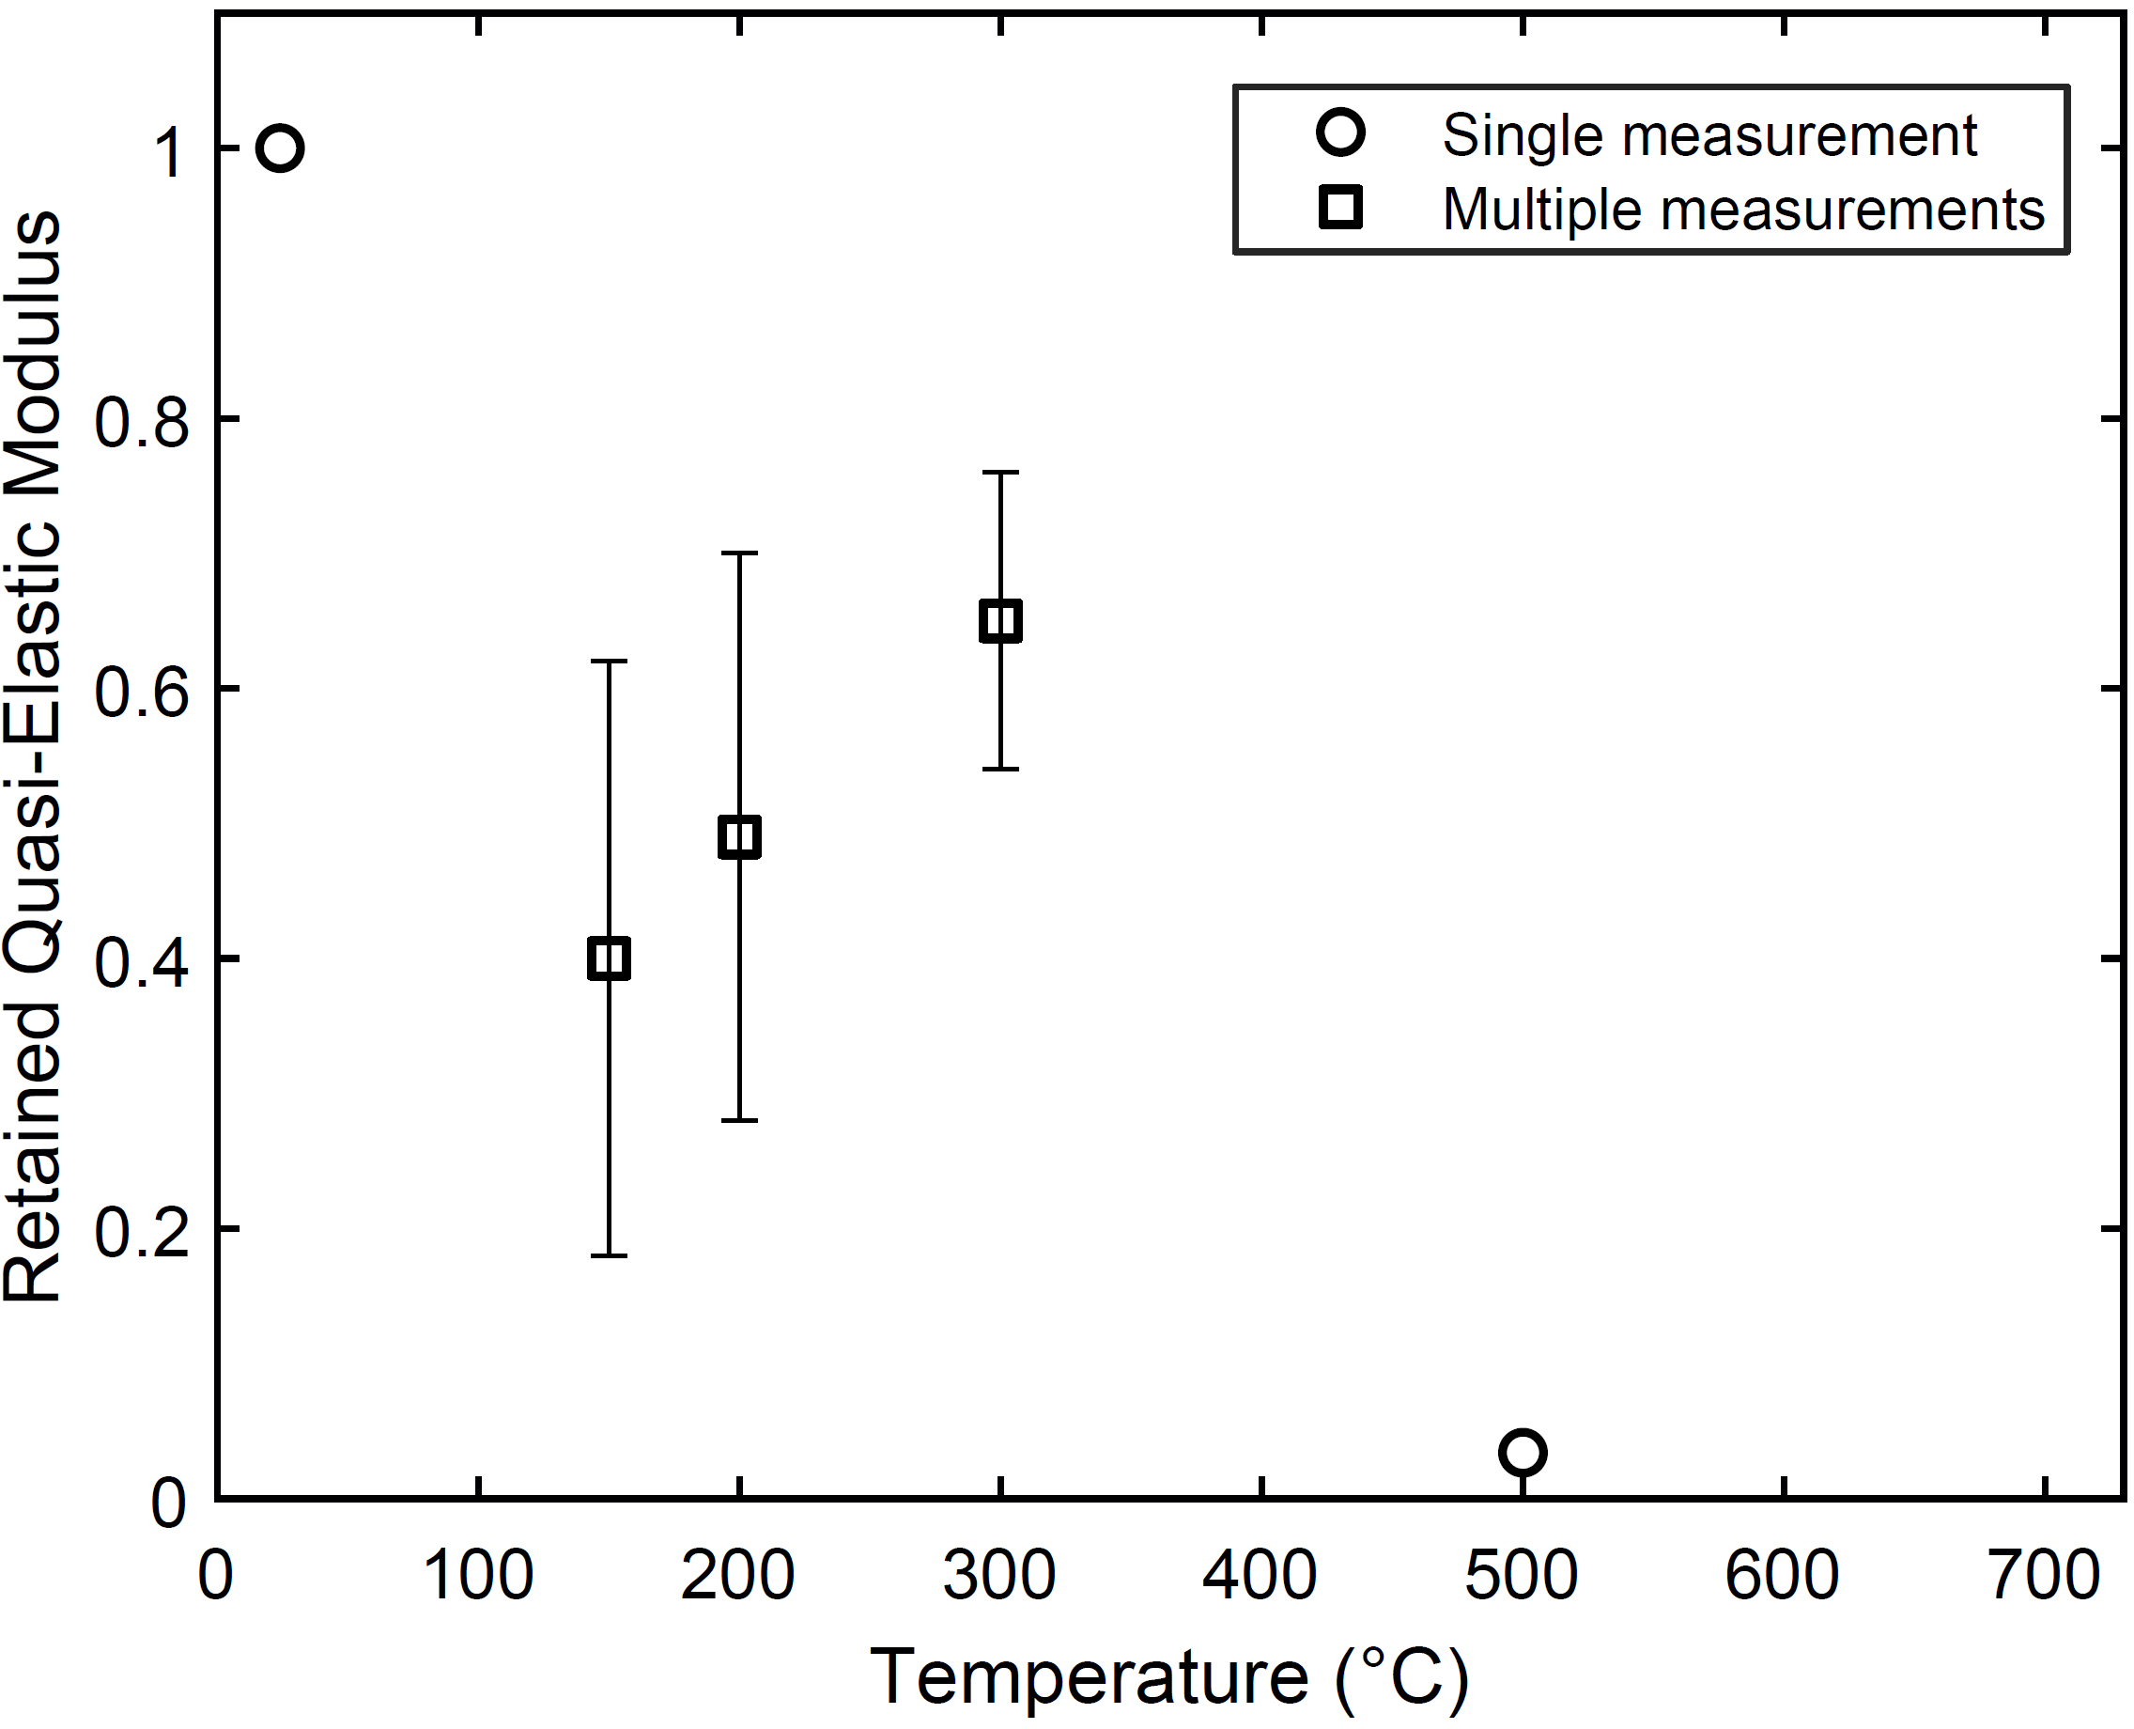

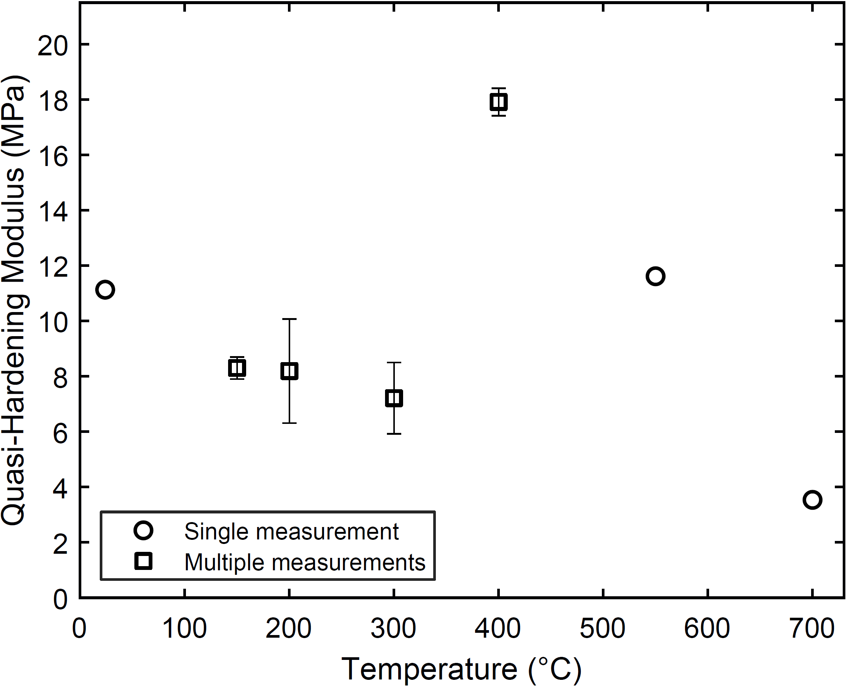
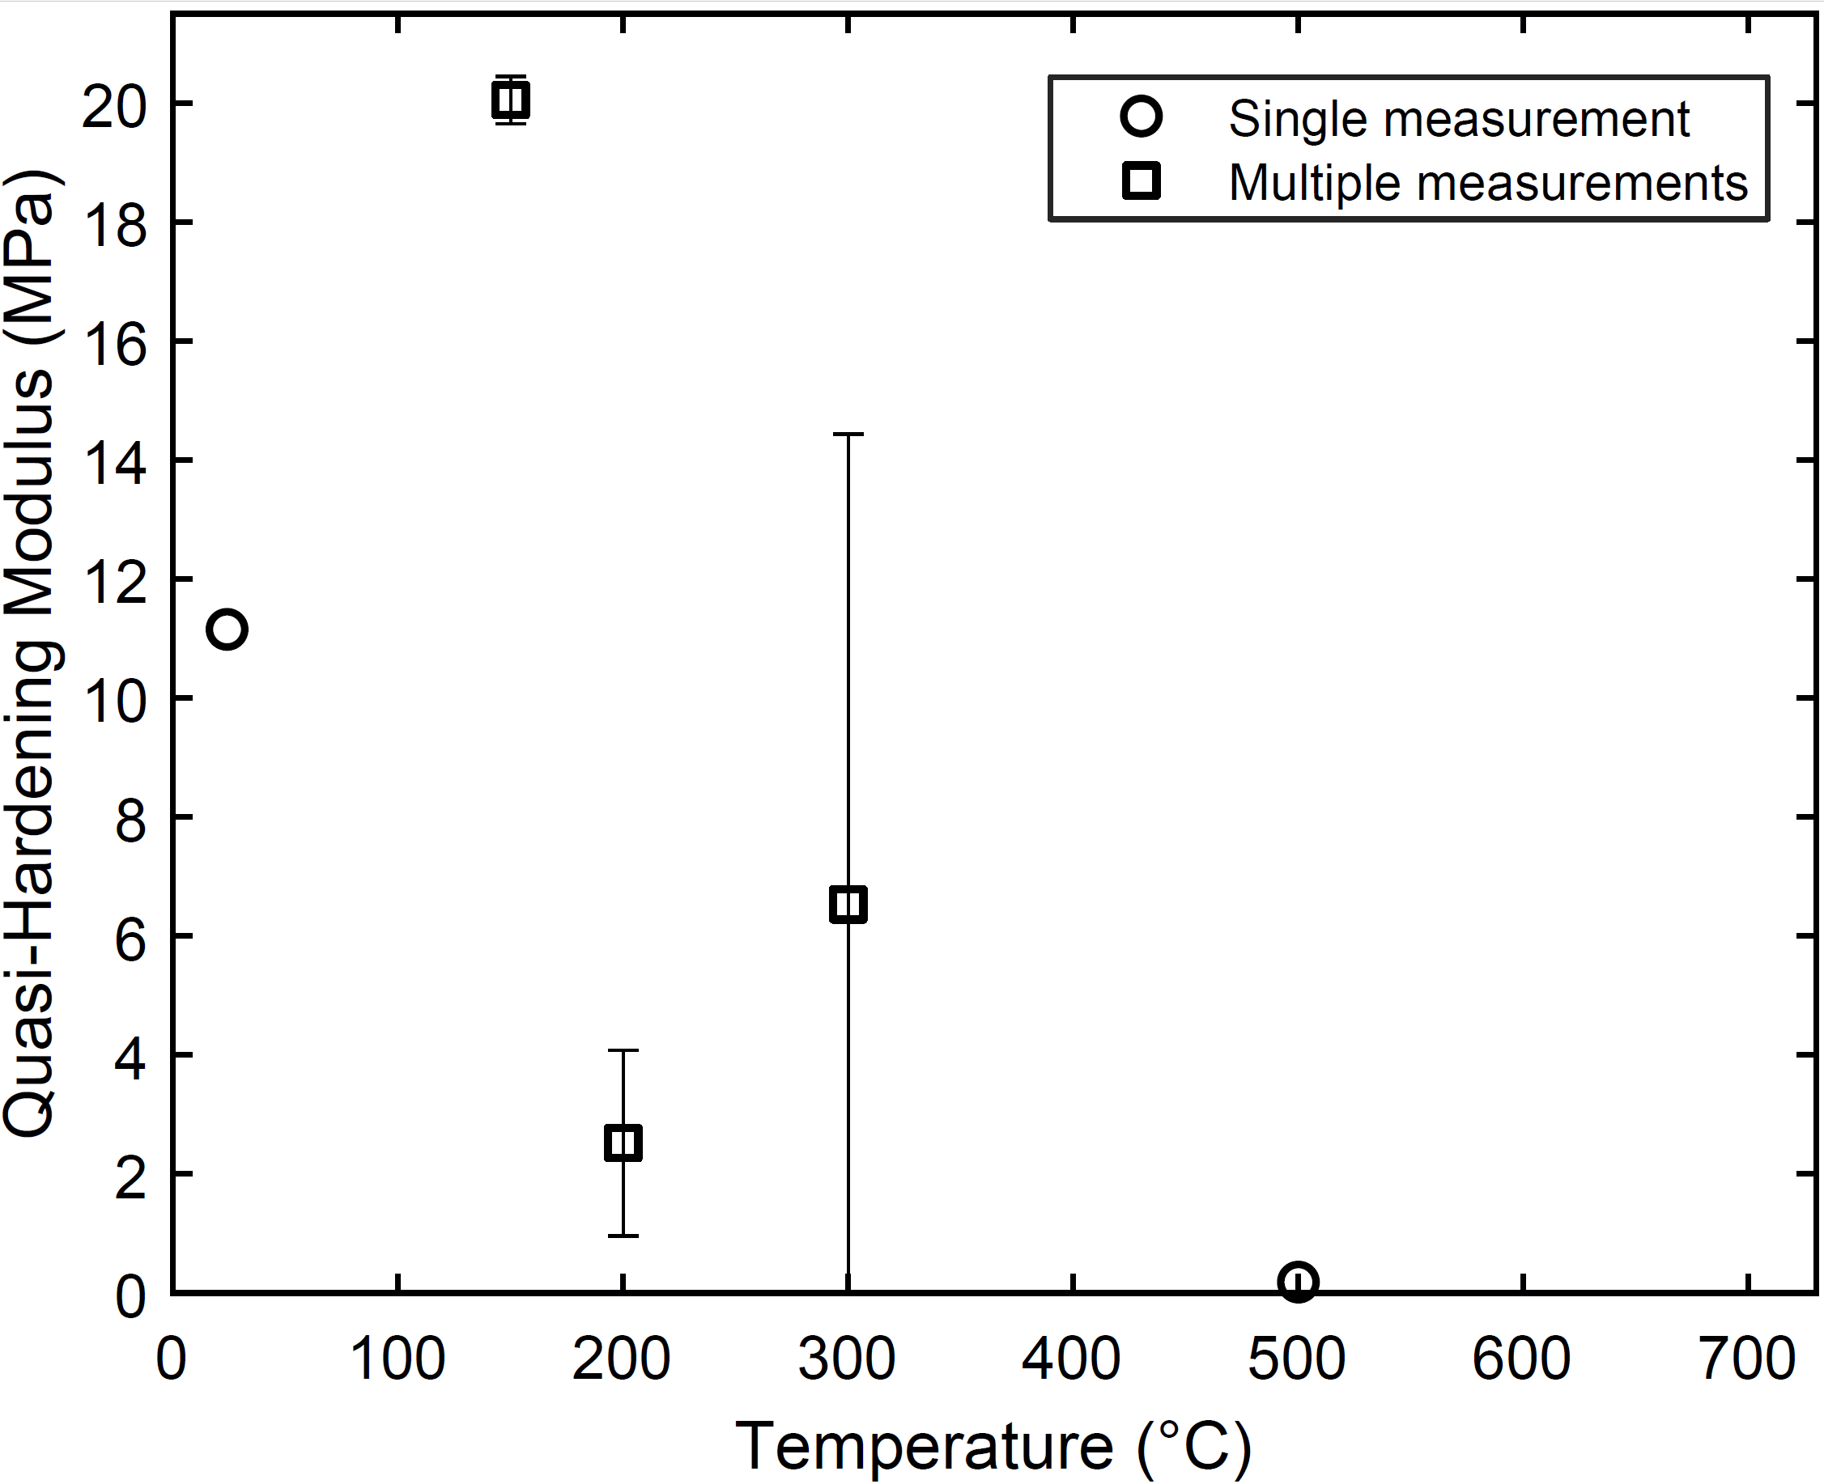

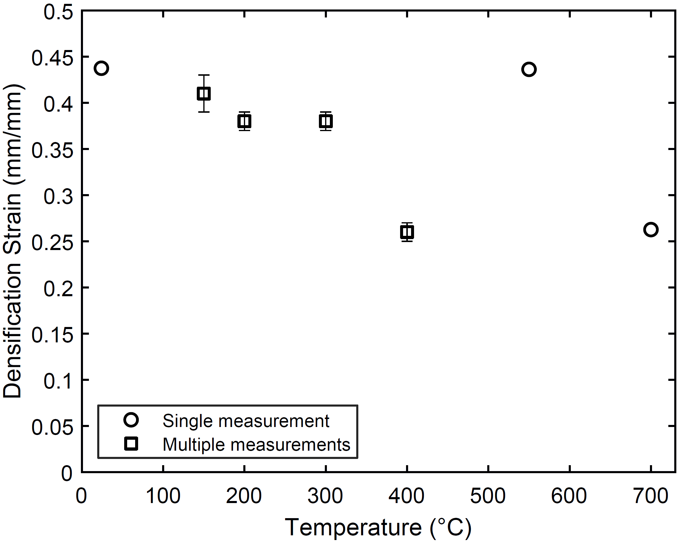
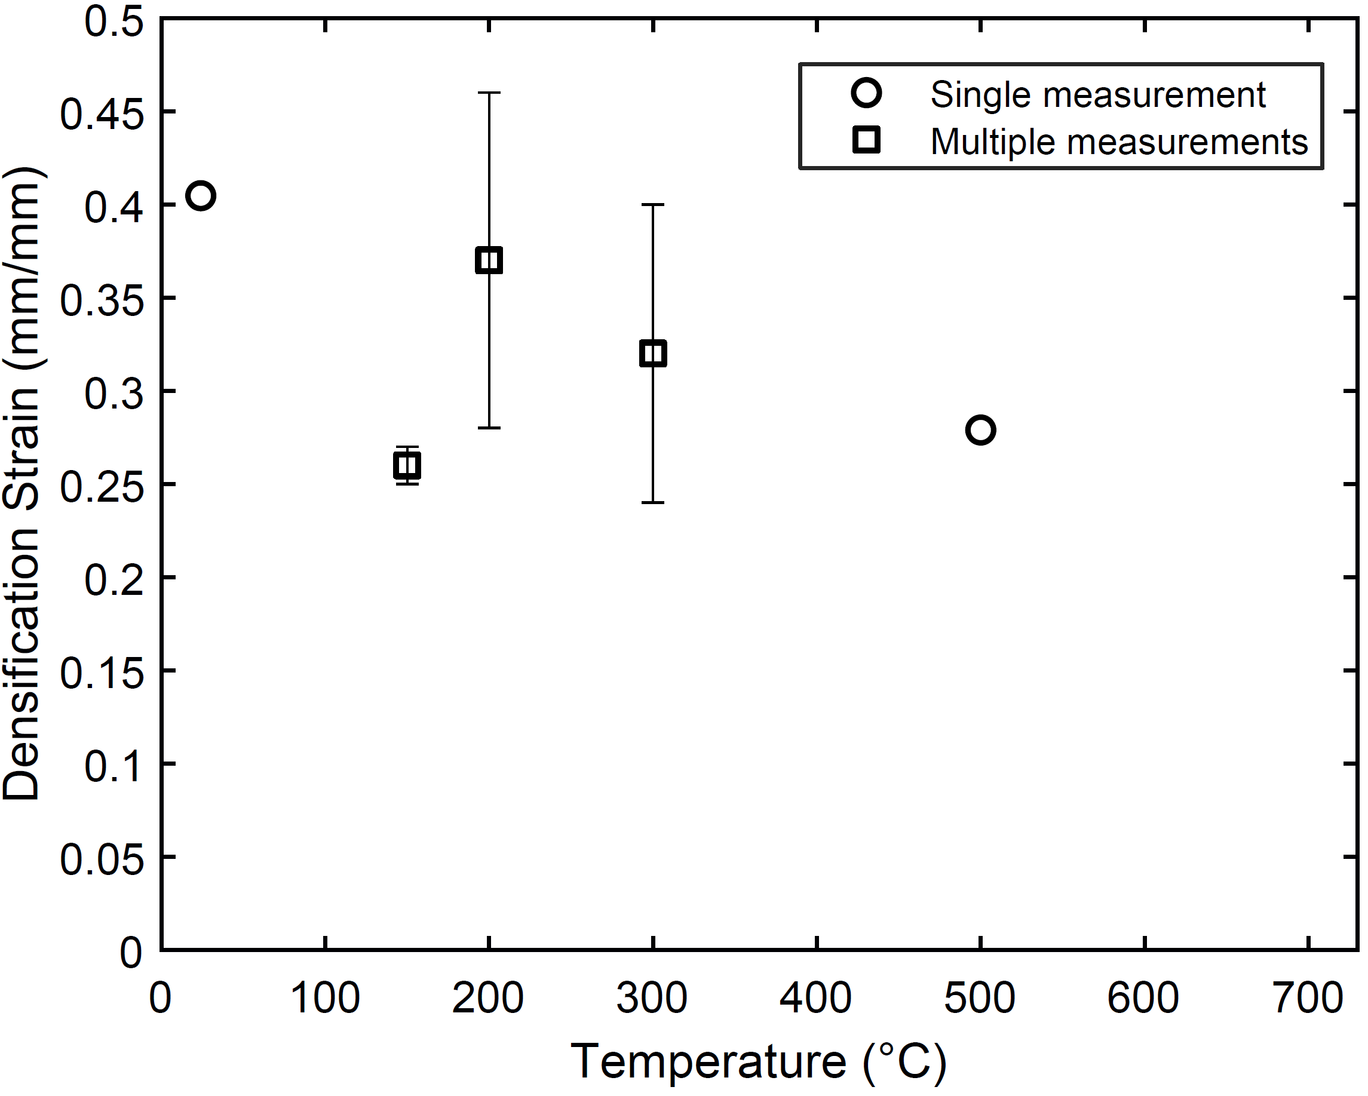

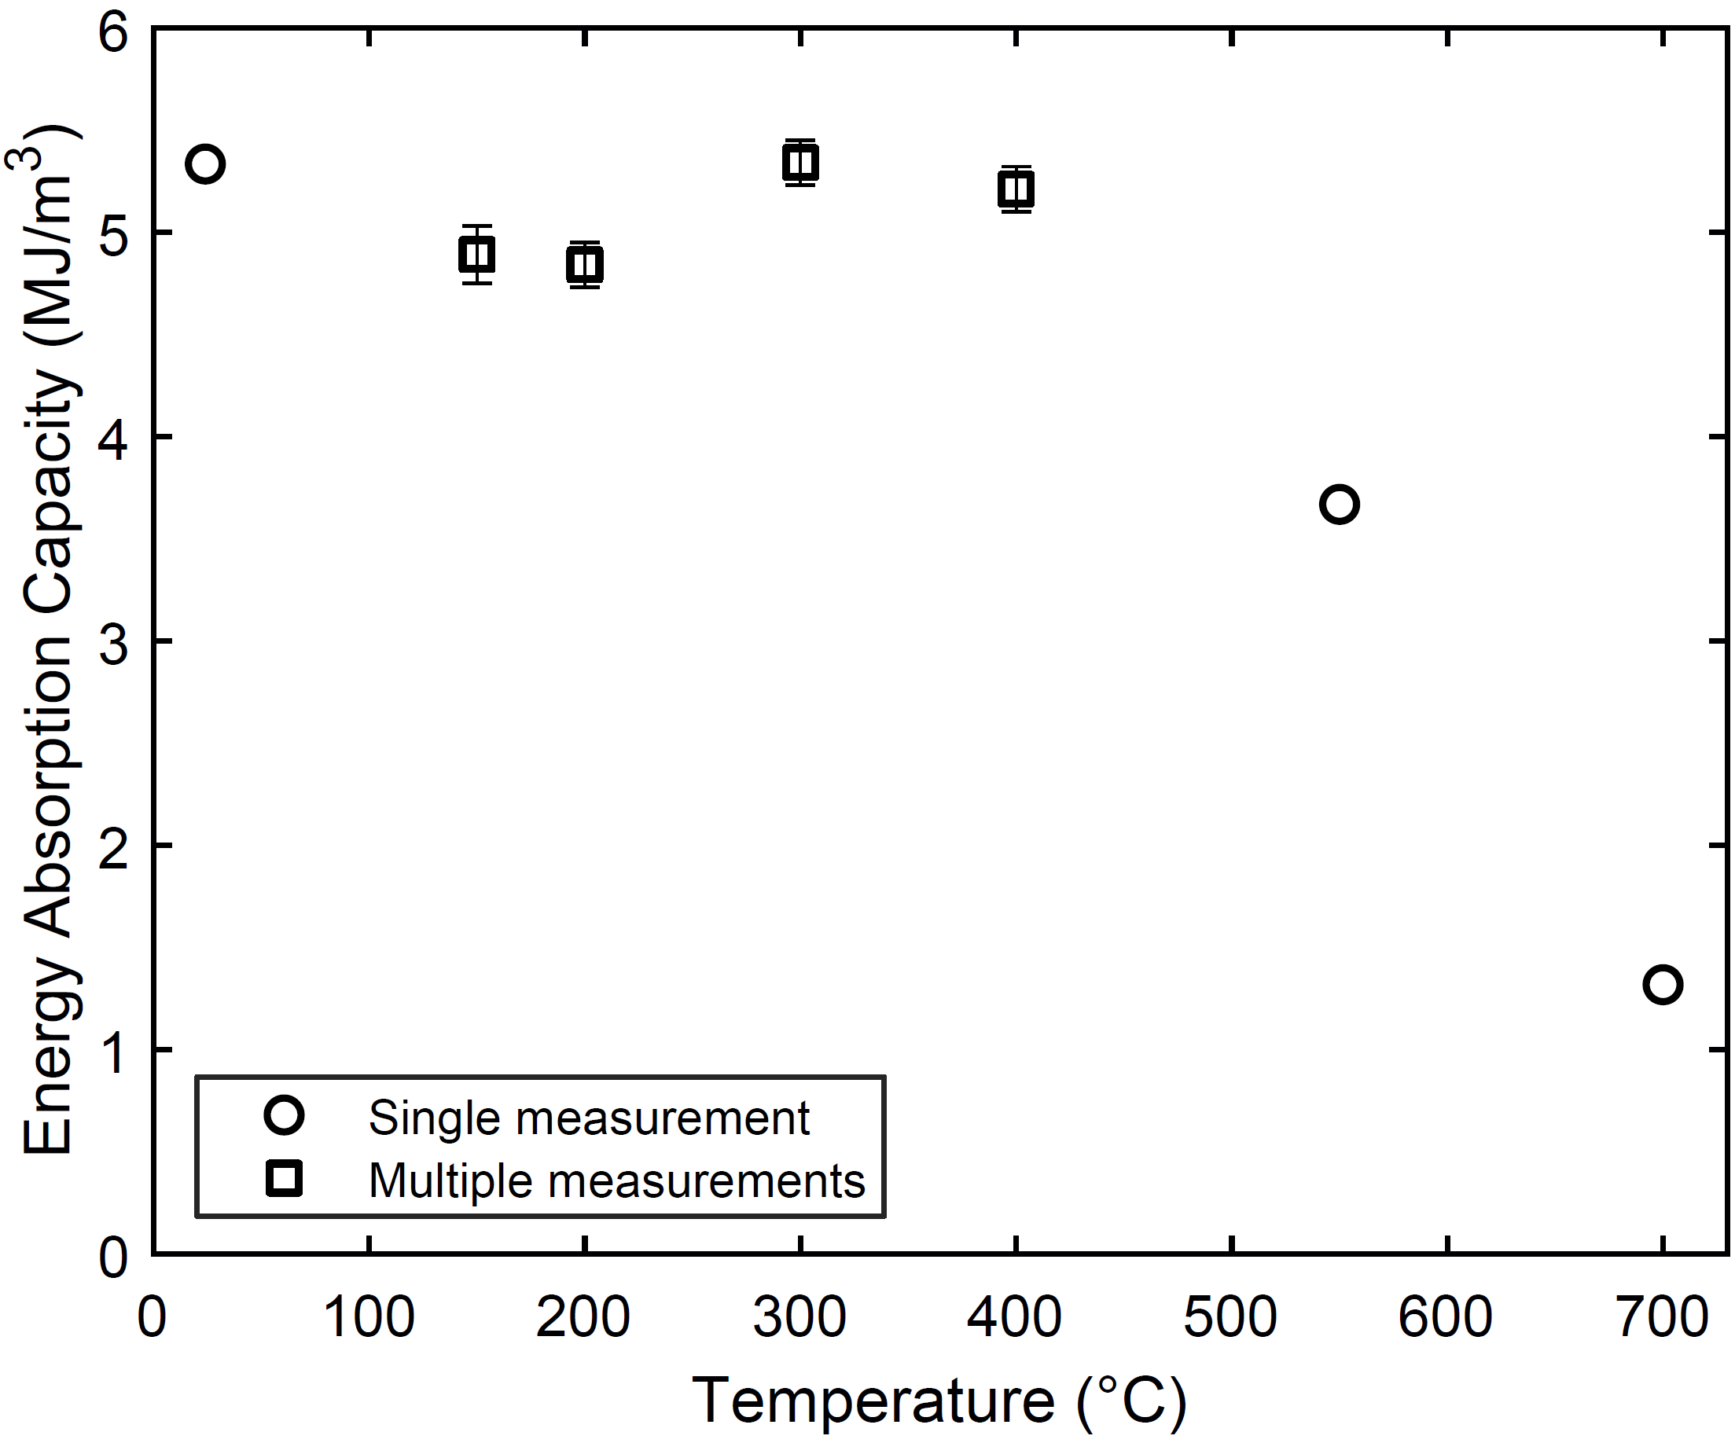
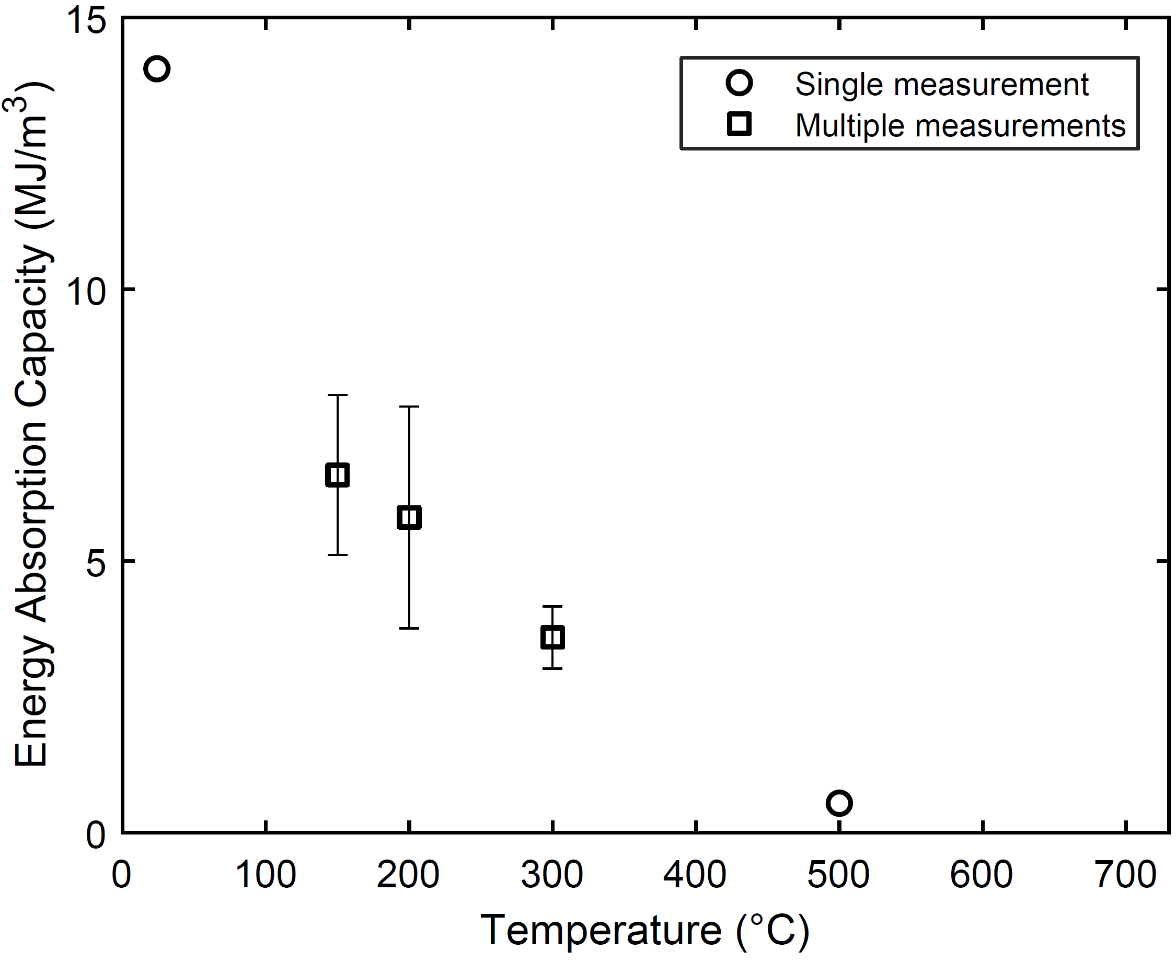
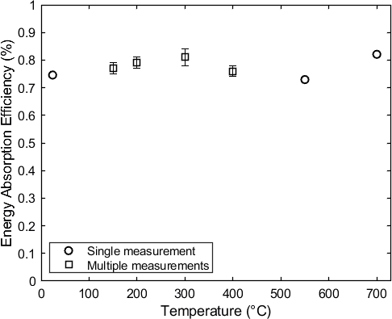
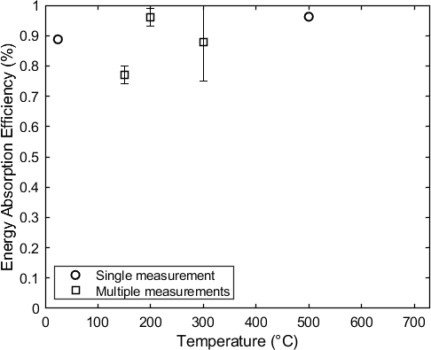

We, however, believe that these figures should not be included in the manuscript, since standard deviation is being calculated, in most cases, based on only four, three or two values. It is a questionable practice to convert three or two values into two other quantities (mean and standard deviation); as such, they mostly lose their meaning.

An alternative is to use the Student’s t-distribution to determine, for example, a two-sided error bar with 95% confidence level, but the Student’s t-distribution with n-1 degrees of freedom, where n is equal to 2 (number of data points in some cases), would result in a multiplicative factor of 12.71 – a very high factor – on the sample standard deviation, instead of the well-known 1.96 factor used for infinity many data points.

Since the authors used the experiments to validate and confirm simulations, an analytical derivations, plotting the actual data points reduces the risk of the reader’s misunderstanding. It is important to note that we have not used experiments to derive empirical observations but to validate and cross-check our computational and analytical results.

Q9: Figure 20 can be deleted because it is not representative.

Action: We used representative test data of steel alloy at ambient temperature, instead of the previously used schematic. Thus the figure is now representative, and we would like to retain in the manuscript.

Q10: Some tabular results of the compressive properties are encouraged to be presented.’

Action: Tabulated test data are now included in the supplementary materials. A sample of these tabulated data are included in the screenshot shown below:
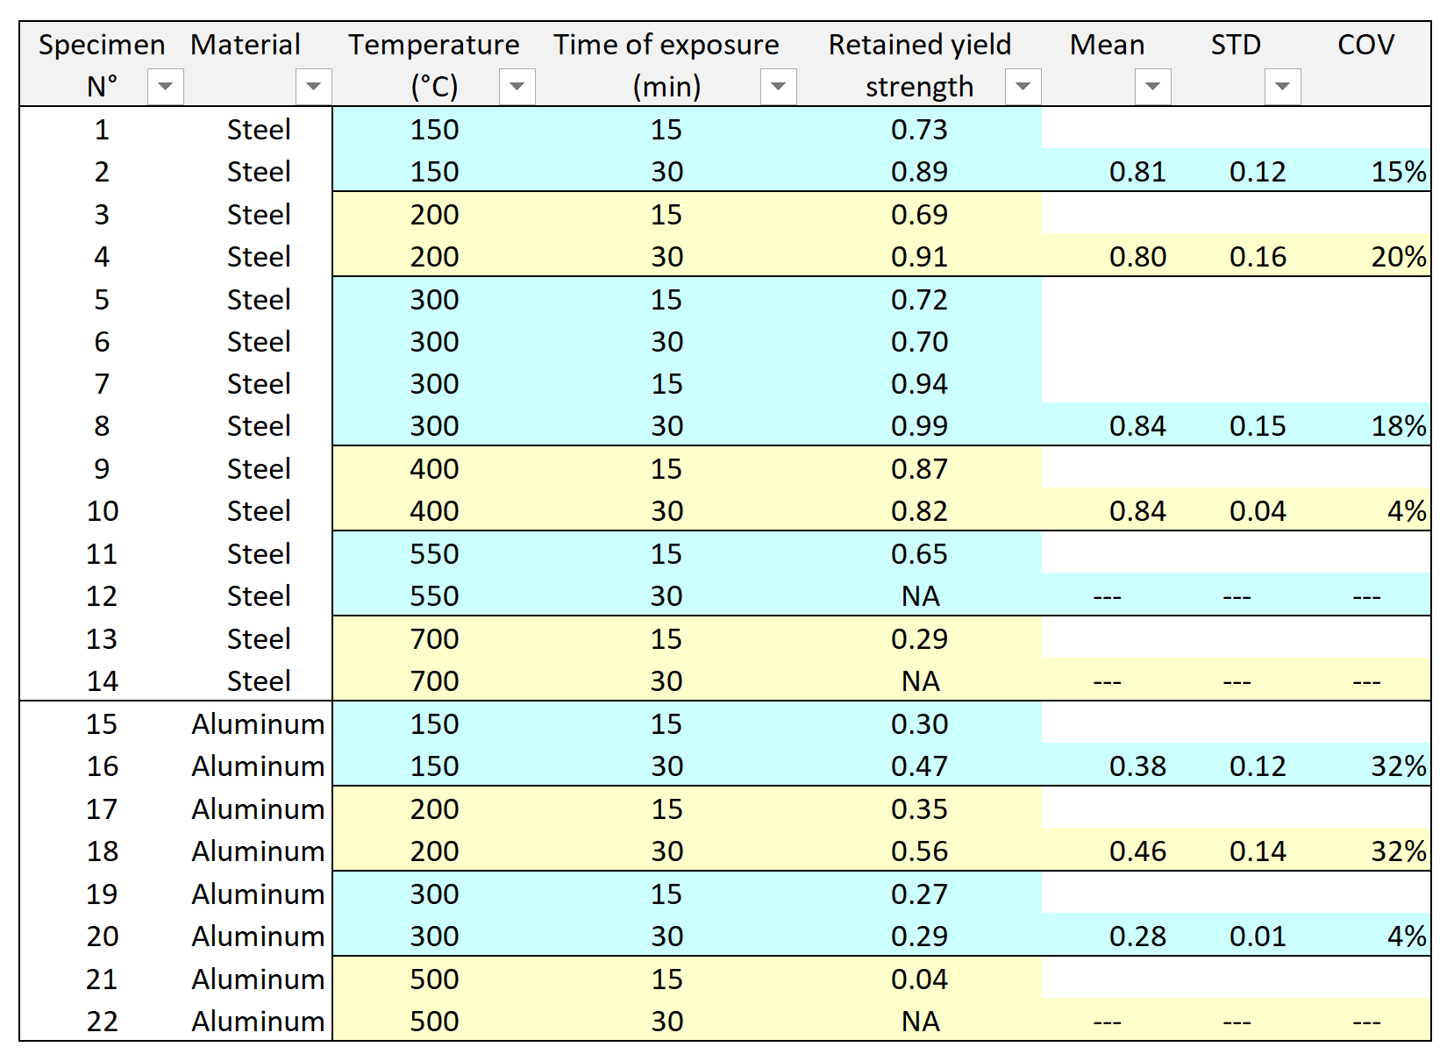

Q11: The reference list must be standardized because abbreviations or complete Journal names are used.

Action: The reference list has been standardized to use only complete journal names.

Q12: The used Standards must be presented also in References list.

Action: All Standards used in the manuscript were added to the References.

Q13: The Introduction section must be improved. There are certain research groups (Movahedi et al., Linul et al., Marsavina et al., Fiedler et al., etc.) dealing with the compressive behavior of different metallic foams at room and low/high temperature testing conditions. Please refer to their works in the Introduction section.

Action: The introduction has been revised and expanded to include additional recent references across a variety of materials journals. In addition to the citations that were included in that section in the previous revision, citations to the following papers were added:
- D.P. Mondal, N. Jha, A. Badkul, S. Das, R. Khedle. “High temperature compressive deformation bahaviour of aluminum syntactic foam.” Materials Science and Engineering A, 534 (2012), 521–529. doi:10.1016/j.msea.2011.16512.002.
- N. Bekoz, E. Oktay. “High temperature mechanical properties of low alloy steel foams produced by powder metallurgy.” Materials and Design, 53 (2014), 482–489. doi:10.1016/j.matdes.2013.07.050.
- N. Movahedi and E. Linul. “Quasi-static compressive behavior of the ex-situ aluminum-alloy foam-filled tubes under elevated temperatures.” Materials Letters, 206 (2017), 182–184. doi:10.1016/j.matlet.2017.07.018.
- E. Linul, N. Movahedi, L. Marsavina. “The temperature effect on the axial quasi-static compressive behavior of ex-situ aluminum foam-filled tubes.” Composite Structures, 180 (2017), 709–722. doi:10.1016/j.compstruct.2017.08.034.
- E. Linul, D. Lell, N. Movahedi, C. Codrean, T. Fiedler. “Compressive properties of zinc syntactic foams at elevated temperatures.” Composites Part B, 167 (2019) 122–134. doi:10.1016/j.compositesb.2018.12.019.

Q14: Some recent developments published in the International Journal of Mechanical Sciences should be considered, showing continuity between the present work and those reported in the literature on similar topics.

Action: Citations to a number of recent articles were added from the International Journal of Mechanical Sciences, which address the effects of the elevated temperature on the mechanical properties of material systems. These include:
- Richeton, J., Ahzi, S., Vecchio, K.S., Jiang, F.C., Adharapurapu, R.R., 2006. Influence of temperature and strain rate on the mechanical behavior of three amorphous polymers: Characterization and modeling of the compressive yield stress. International Journal of Solids and Structures 43, 2318–2335.
- Thomas, J.D., Triantafyllidis, N., 2007. Theory of necking localization in unconstrained electromagnetic expansion of thin sheets. International Journal of Solids and Structures 44, 6744–6767.
- Zhang, Y., Liu, W., Yin, C., Ma, Y., Wang, L., 2020. Mode II interfacial fracture characterization of foam core sandwich materials at elevated temperatures: the effects of frictional stresses between the crack edges. International Journal of Solids and Structures 193–194, 28–38.

Q15: English is not the native language of this Reviewer; however, the manuscript requires some grammatical corrections.

Action: A comprehensive editorial review was conducted to improve the language and grammar of this manuscript.

